Study questions for Bio 230, exam 2

- What must be regenerated in glycolysis in order for reactions to proceed?
- What does an enzyme do that speeds up a reaction, in terms of energetics?
- The ΔG of a reaction is -5 kcal/mol. An enzyme is added at high concentration to catalyze the reaction. What is the ΔG now?
- Describe a mechanism by which the ES complex promotes the transition to EP.

- 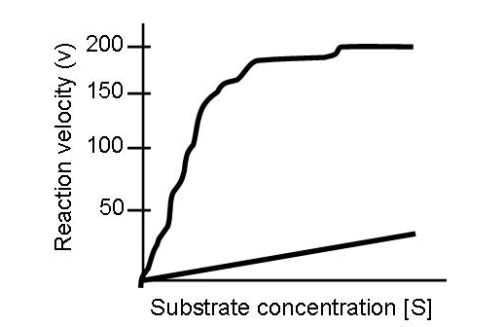In the above diagram, what is Vmax? Draw a line showing where Km falls. What is the reaction velocity at Km?

- 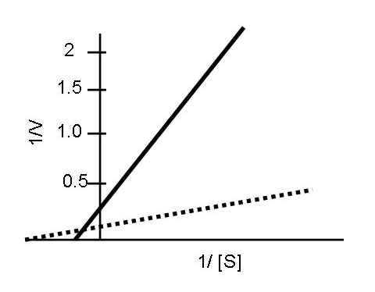In the above diagram, which line is the catalyzed reaction (solid or dashed), and how can you tell?
- On the same plot, draw a line showing a) competitive inhibition b) classic non-competitive inhibition c) mixed non-competitive inhibition.
- What is pyruvate converted to in order to begin the TCA cycle?
- Suppose a toxin prevents the dissociation of CoA from succinyl-CoA. How many NADH molecules have been produced from each pyruvate in this scenario? How many FADH molecules have been produced? Assuming a continuing supply of pyruvate, what would have to be added to the medium or into the cell to continue producing NADH?
- Why are fatty acids able to ultimately produce so much more ATP than glucose molecules?
- What is the source of energy used to drive the formation of ATP?

- 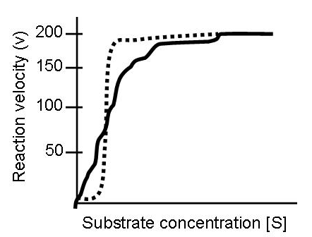If the solid line represents standard Michaelis Menten kinetics, is the Hill coefficient of the dashed line in the above plot >1, <1, 1, or 0? What type of cooperativity does this plot depict?

- What advantage, if any, does positive cooperativity provide at high [S]? At moderate [S]?
- What kind of organism reaches equilibrium?
- one that is actively metabolizing
- one with a low metabolic rate
- a dead organism
- a eukaryote
- a prokaryote
- Doubling the concentration of enzyme will ______ the V_{max} and _____ the K_{M}.
 |  | - double, not alter
 |  | - not alter, double
 |  | - double, double
 |  | - not change, not alter
 |  | - halve, halve
- What kind of inhibitor binds very tightly to an enzyme often forming a covalent bond with an amino acid in the active site?
 | A) |  | irreversible
 | B) |  | reversible
 | C) |  | uncompetitive
 | D) |  | reversible and uncompetitive
 | E) |  | None of these are correct.
- In what ways can pyruvate and NADH be metabolized in anaerobic respiration? In aerobic respiration?
- What molecule is responsible for conveying 2 carbons from pyruvate to the Krebs cycle
23. In which of the compartments or membranes would the following things be found?
a) | Glycolytic enzymes.
b) | Electron transport system.
c) | Krebs Cycle enzymes.
d) | ATP synthase.
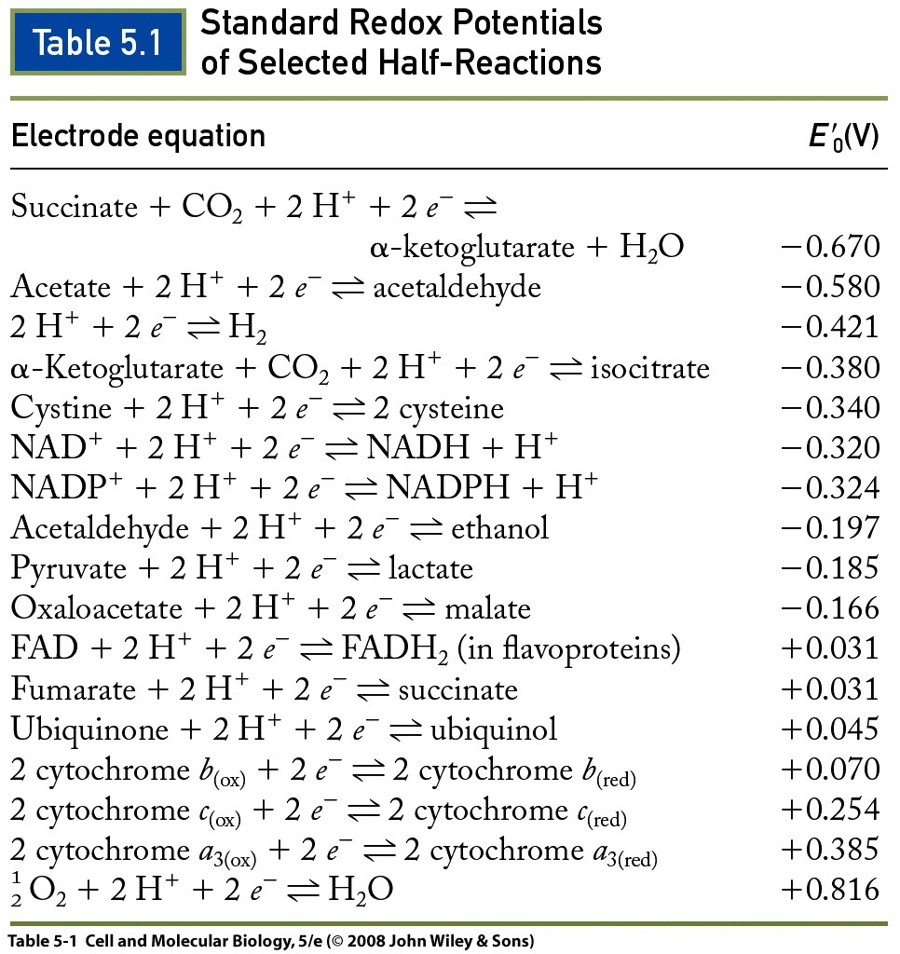
24. Given the table above, will α-ketoglutarate + CO2 + 2H+ spontaneously form isocitrate? Why or why not?
25. Using the same table above, name one molecule that NADH would donate electrons to and one molecule that NAD+ would accept electrons from.

26. Which steps in the electron transport chain would be blocked by limiting motion within the inner mitochondrial membrane?

27. Describe the three conformations of the beta subunit in ATP synthase.
- Would a mutated ATP synthase without a gamma subunit be able to produce ATP? Why or why not?

- What is the role of H+ translocation in generating ATP by ATP synthase?

- Describe one way that the kinetics of the TCA cycle are regulated.

- If a toxin inserts sodium-permeable channels into the inner mitochondrial membrane, what will happen to the proton motive force and why?

